Sydney Larson’s Volunteer Experience with Renewable Energy Enterprises Foundation

2012

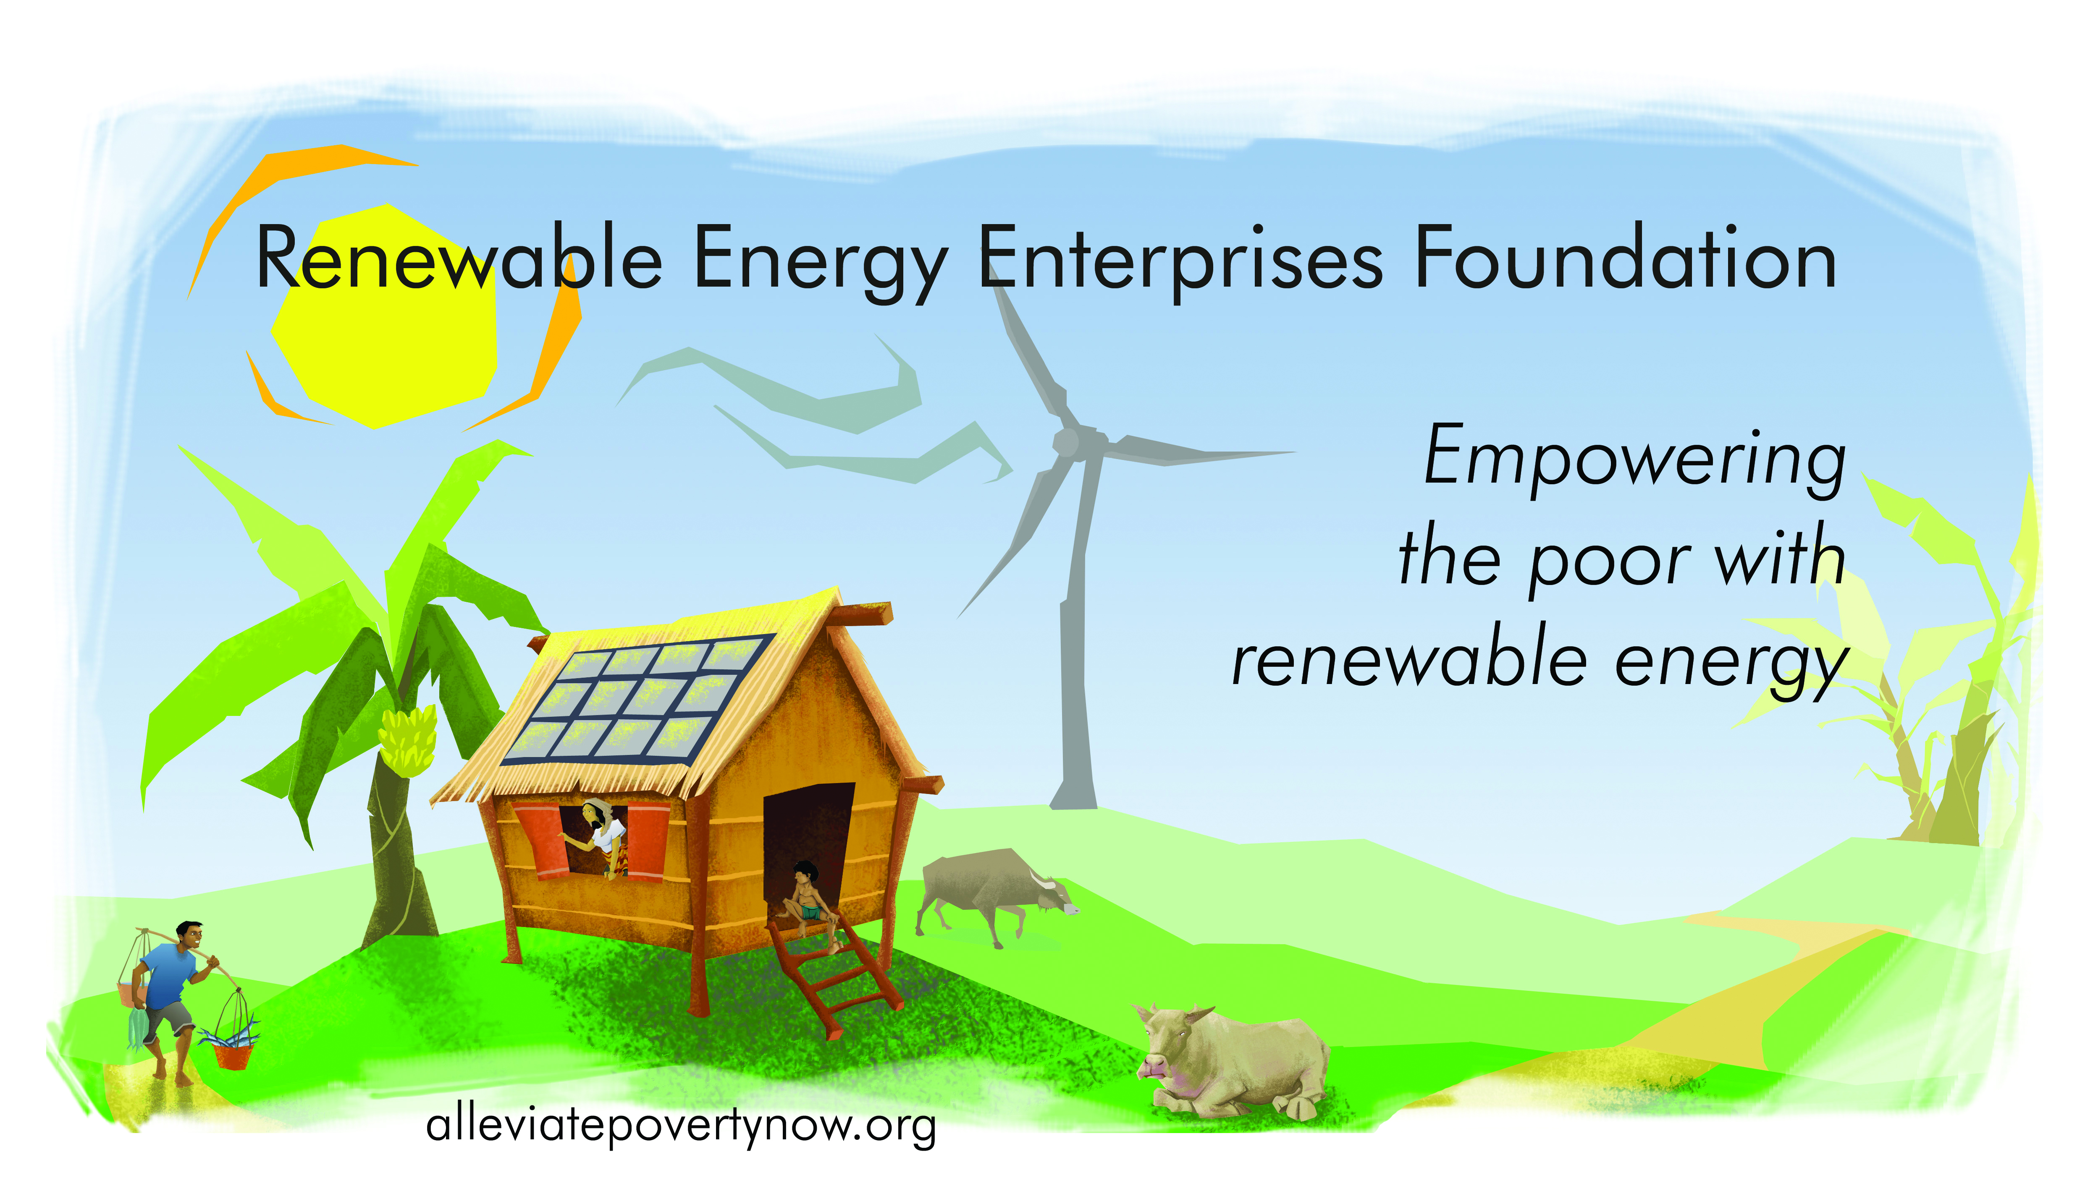

Brian and I are relaxing in our San Francisco apartment as I re-live my ten-day trip to the Philippines through the four hundred or so photos I took. “Oh, those are the bait fish?” he inquires. “No,” I laugh and reply, “that’s their catch! There’s a *Finding Nemo* fish over there. See?” and I point at the photo. But the smile on my face is fleeting. I put the computer down, turn toward him, and say, “Catching that half basket of fish took those eight men most of a day and they probably earned around 300 pesos for it. That’s just over $7, so less than a dollar per person. Can you believe that?” Brian stares in amazement but says nothing, so I continue, “Depending on the size of each man’s family, these people might be better off than a lot of the families I met.”

To say my trip was eye opening would be extraordinarily cliché, but there’s no other succinct way to describe the time I spent in Candelaria. I had very little idea of what to expect; I had never traveled to Asia or to an impoverished area in any country and hadn’t spent much time in a rural area, even in the U.S. What I found was a place unlike any I had experienced and a people who were unimaginably hospitable while living in situations that my western mind could hardly comprehend.

For two of my ten days we trekked around Candelaria in search of the 16 families nominated by their Barangay captains as potential recipients for a solar lantern or an efficient cook stove. We’d start off in the general direction specified by the Barangay captain, guided by the Chesley family’s house hand, Ka Enciong Florencio Atrero. A few hundred meters later Ka Enciong would quietly gesture from the back seat and we’d stop. He’d hop out of the car and into the heat, ask someone where the family lived, and then we’d be off again a little while longer, kicking up dust as we went. This start and stop process usually repeated two or three times before we finally arrived at our intended destination. Once there, we’d politely exchange greetings, explain what we were doing, and then I’d launch into the interview questions. Between gestures, a few Spanish words, and some broken English, we were able to communicate.

One thing in particular struck me about these interviews: how challenging it was to ascertain the annual income of each family. In the U.S., most people easily rattle off their annual income without a second thought. But for the seasonal farmer or day laborer who takes jobs as they come -- intermittently -- it’s a difficult question. So, I quickly altered my approach, first asking what they did for “trabajo” and then firing off a series of follow-up questions: “How many hours a day do you do that when you’re working?”

“How many days might you do that during a month?” “How many months in a year?” This questioning typically revealed a situation that seemed hardly livable: an income between $2 and $10 per family member per month. And yet, from a casual conversation and their smiling faces, you’d never guess just how dire their situation was.

After each interview, we’d ask permission to take photos of their house and each family enthusiastically gestured us into their home. “Makeshift” was a common theme and perhaps one of the only appropriate descriptors for these homes. Most of the structures were pieced together using a mélange of materials: plywood, bamboo, a few cinder blocks, towels, and even posters from the most recent election. A few homes appeared more orderly and well kempt but were made entirely out soft materials like bamboo and woven nipa. As I wandered around the exterior, I marveled at how beautiful they were but couldn’t even begin to imagine how they’d survive the next monsoon season or how I’d fare living in one, monsoon or not. Indeed, one bamboo and nipa homes looked like it had been warped in Photoshop; the whole structure was skewed off its vertical axis.

Now that I’m back at home, friends often inquire what the people were like. In a word? Hospitable. Many of the people I interacted with were extremely poor, even by Filipino standards, and yet they eagerly welcomed us into their homes. Before knowing the reason for our visit, the mother would send one of her (many) children inside to fetch chairs or a bench, clean it off, and then enthusiastically invite us to take a seat. One man was actually bathing when we arrived. Instead of waving us off or slamming the proverbial door in our faces, this man warmly encouraged us to stay and toweled off throughout our conversation.

We also experienced this aspect of the Filipino culture when we dropped in on a family who had some coconut seedlings to sell Ralph. It’s part of the Filipino culture to show up unannounced, so they had no idea we were coming. Once we arrived, they continually offered us snacks. “Halo halo with plantain, ice, and milk? Sincamas?” After chatting and strolling around their property for an hour to get a good view of the bangus fish ponds and mangrove forests, we started to go through the motions of departure. The family immediately objected and insisted, “We’re cooking you lunch!” We politely accepted the invitation and feasted on freshly caught grilled and fried bangus, sinagong, green mango, and -- of course -- lots of rice.

It’s easy to sit comfortably in an air-conditioned apartment watching documentaries about other countries and cultures on your 50 inch flat screen TV; it’s a completely different story to experience those places and people in-person. Traveling to Candelaria with REEF is one of the most unusual, rewarding, and challenging travel adventures I’ve had and I’m very thankful for the experience.